|  |  |  |  |  |
| --- | --- | --- | --- | --- |
| **import** pandas **as** pd **import** numpy **as** np |  |  |  |  |
|  |  |  |  |  |
| data **=** pd**.**read_csv("diabetes.csv") |  |  |  |  |
|  |  |  |  |  |
| data**.**head() |  |  |  |  |
| **Pregnancies Glucose BloodPressure SkinThickness** | **Insulin** | **BMI** | **DiabetesPedigreeFunction** | **Age Outcome** |

In [22]:

In [23]:

In [24]:

Out[24]:

**0** 6 148 72 35 0 33.6 0.627 50 1

|  |  |  |  |  |  |  |  |  |  |  |  |  |  |  |
| --- | --- | --- | --- | --- | --- | --- | --- | --- | --- | --- | --- | --- | --- | --- |
| **1** |  | 1 |  | 85 |  | 66 | 29 | 0 | 26.6 |  | 0.351 | 31 |  |  |
| **2** |  | 8 |  | 183 |  | 64 | 0 | 0 | 23.3 |  | 0.672 | 32 |  |  |
| **3** |  | 1 |  | 89 |  | 66 | 23 | 94 | 28.1 |  | 0.167 | 21 |  |  |
| **4** |  | 0 |  | 137 |  | 40 | 35 | 168 | 43.1 |  | 2.288 | 33 |  |  |

0

1

0

1

**

**

In [25]: data**.**isnull()**.**sum()

|  |  |
| --- | --- |
| Out[25]: | Pregnancies 0  Glucose 0  BloodPressure 0 SkinThickness 0  Insulin 0  BMI 0  DiabetesPedigreeFunction 0 Age 0 Outcome 0 dtype: int64 |

In [26]: X **=** data**.**drop(columns**=**['Outcome']) y **=** data['Outcome']

In [27]: **from** sklearn.model_selection **import** train_test_split

X_train, X_test, y_train, y_test **=** train_test_split(X, y, test_size**=**0.2, random_state**=**42)

In [28]: **from** sklearn.naive_bayes **import** GaussianNB gaussian **=** GaussianNB() gaussian**.**fit(X_train, y_train)

Out[28]: ▾GaussianNB

GaussianNB()

In [29]: Y_pred **=** gaussian**.**predict(X_test)

In [37]: **from** sklearn.metrics **import** precision_score, confusion_matrix, accuracy_score, recall_score accuracy **=** accuracy_score(y_test,Y_pred) print("Accuracy: ",accuracy,"\nAccuracy(%): ",accuracy**\***100) error**=**1**-**accuracy print("Error Rate: ",error,"\nError rate (%):",error**\***100)

Accuracy: 0.7662337662337663

Accuracy(%): 76.62337662337663

Error Rate: 0.23376623376623373

Error rate (%): 23.376623376623375

In [31]: precision **=**precision_score(y_test, Y_pred,average**=**'micro') print("Precision: ", precision,"\nPrecision(%): ", precision**%100**)

Precision: 0.7662337662337663

Precision(%): 0.7662337662337663

In [32]: recall **=** recall_score(y_test, Y_pred,average**=**'micro')

print("Recall: ", recall,"\nRecall(%): ", recall**\***100)

Recall: 0.7662337662337663

Recall(%): 76.62337662337663

In [33]: cm **=** confusion_matrix(y_test, Y_pred) print("Confusion Matrix: \n",cm)

Confusion Matrix:

[[79 20]

[16 39]]

|  |
| --- |
| **import** matplotlib.pyplot **as** plt **import** seaborn **as** sns plt**.**figure(figsize**=**(6,4))  sns**.**heatmap(cm, annot**=True**, fmt**=**'d', cmap**=**'Blues', xticklabels**=**['No Diabetes', 'Diabetes'], y plt**.**xlabel('Predicted') plt**.**ylabel('Actual') plt**.**title('Confusion Matrix') plt**.**show() |

In [34]:

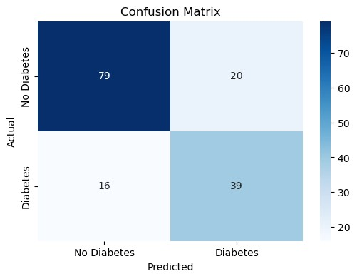

|  |
| --- |
|  |

In [ ]: